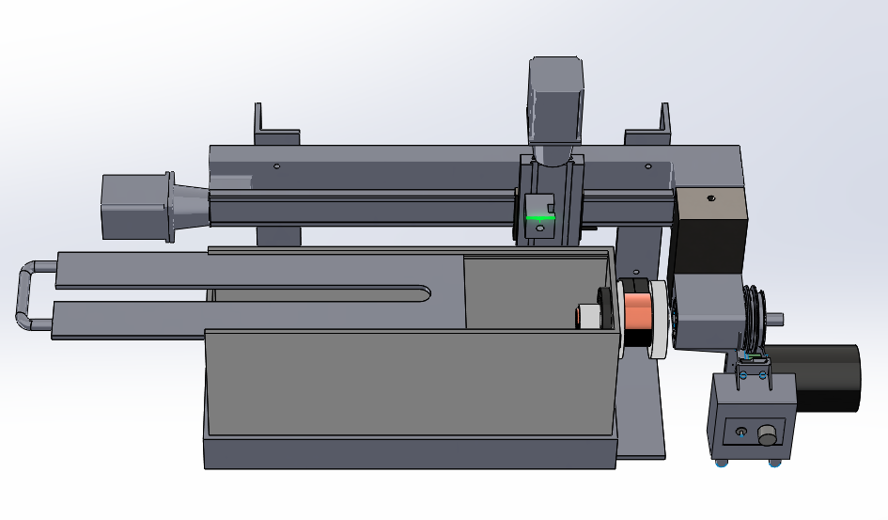

Mid-Year Project Report

ECM Lathe

ME 755

12 December 2016

Simon Popecki (Project Manager)

Carlos Giacomo Graniello

Faculty Advisor: Yannis Korkolis

Industry Advisor/Sponsor: Tim Noronha, TURBOCAM International

Disclaimer

This document is provided as part of the requirements of Mechanical Engineering course ME 755 & 756, at the University of New Hampshire. It does not constitute a professional engineering design document. Although the information is intended to be accurate, students, instructors, and the University of New Hampshire make no claims, promises, or guarantees about the accuracy, completeness, or adequacy of the information. The user of this document shall ensure that its use does not violate New Hampshire law with regard to professional licensing and certification requirements, including any work resulting from this student-prepared document required to be under the responsible charge of a licensed engineer.

Table of Contents

Disclaimer ii

Table of Contents iii

List of Figures iii

List of Tables iii

Introduction 5

Scope of Work 5

Schedule 7

Analysis & Calculations 8

Summary 10

Bibliography 11

Layout and Detailed Drawings 11

List of Figures

Figure 1: Caption for figure #

Figure 2: Caption for figure #

List of Tables

Table 1: Caption for table #

Table 2: Caption for table #

Introduction

Electrochemical Machining (ECM) takes advantage of the corrosion properties of conductive substances to atomically remove material at a microscopic level without tool-workpiece contact. ECM can be thought of as reverse electroplating – the workpiece is anodic and the tool is cathodic. Electrons flow from the cathode to the anode through an electrolyte, and metal ions are ejected from the anode (workpiece). The liberated metallic ions are washed away by the high pressure (4-8 Bar) electrolyte flow before they are able to electroplate onto the cathode (tool). ECM is ideal for cutting hard materials, as workpiece hardness is irrelevant to the material removal mechanism of ECM. Currently ECM operations are similar to die sinking operations where a cathodic part-negative is fed into a workpiece leaving its three dimensional imprint in the part being machined.

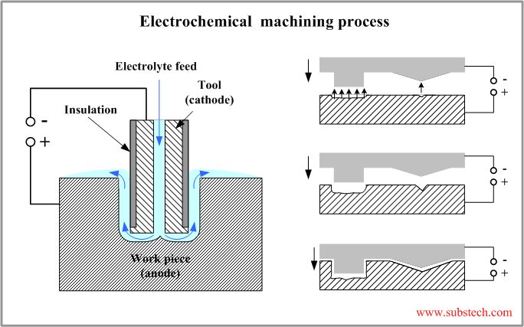

Figure 1

Electrochemical Machining removal rates are governed primarily by material properties such as density and valency, electrolyte conductivity, and the flow of current. The material removal rate is proportional to current flow (McGeough, 1974).

Different materials machine differently with ECM. Commercially pure titanium machines well (Li, Gao, Wang, Qu, & Zhu, 2016), where titanium alloys are comparatively more difficult (Leese, 2016). Inconel 625 machines to a better surface finish than Inconel 725 due to the difference in machining rates between the Inconel and the gamma prime precipitate found in Inconel 725. ECM is commonly used to shape Inconel, Waspalloy, and other superalloys for use in aero-engines due to its indifference towards material hardness.

Modern ECM is used primarily for mass production due to the high capital costs associated with machinery and engineering staff – it is typical for a machine to be designed solely for the production of a single part type while costing in excess of $1,000,000. The introduction of a single machine capable of manufacturing many different geometries would lower ECM development costs significantly. ECM turning operations were practiced during the 1970s (Wilson, 1971), however the technology has since completely fallen out of use. The goal of this project is to re-implement ECM turning with the benefits of modern computing. The ECM lathe will be able to produce parts the same way a conventional lathe does – machinists program movements with G-codes, and the machine cuts the specified geometry without any further input or engineering knowledge. The specific goal of this project is to cut radial features in Titanium 6-4 flowpath components.

Scope of Work

The electrochemical lathe project started its development with the establishment of its parameters. The overall dimensions of the system were estimated by creating a drawing of it in SolidWorks. These dimensions were established by the actual measurements of the main components of a Sherline lathe (e.g. lathe’s bed, spindle, and tool holder). Figure 2.1 is intended to represent a standard Sherline lathe.

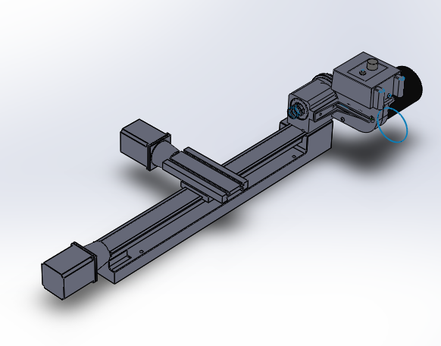

**Figure 2.1:** Lathe Obtained from Sherline Industries

A similar lathe as from the figure above was purchased and is now in the process of modification, so electrochemical technologies can be implemented.

The following diagram represents the system that is going to be created at the project’s completion. It represents the deliverables that need to be satisfied, as well.

|  |
| --- |
| 7  6  1  2  3  4  5  **Figure 2.2**: ECM Lathe System Diagram |

From figure 2.2, the following deliverables can be concluded:

1. CNC- Machine Control Computer:

The ECM lathe will be operated using G-code syntax from a conventional computer or from a USB input on the machine terminal. The USB terminal is still in progress.

1. ECM Lathe:

From figure 2.1, the lathe will be re-engineered so the necessary appliances of an electro chemical machine can be incorporated into it.

1. Dirty Electrolyte Pump:

In a traditional machine, coolant is used for combinational cutting. This one diverges from different kinds of oils. For a conventional ECM the “coolant” that is use to accelerate the dissolution of the metal is known as electrolyte. This fluid will be transported from the cutting chamber to the filter by a pump. Due the nature of the electrolyte, which is mostly salt, a special pump is needed. In addition, a pressure regulation system will be needed to prevent overflowing.

1. Filter Press:

The contaminated electrolyte will travel from the ECM machine to the filter press where it will be filtered. Metal particles are extracted from the electrolyte in the filter press. Early machine testing will take advantage of the TURBOCAM International Electrolyte Management System – a large scale industrial treatment system for sodium nitrate electrolyte set up in Barrington NH at TURBOCAM B2.

1. Electrolyte Storage tank:

One of the many challenges of the project is to design a system that could be relatively easy to transport. This means that a storage tank needs to be designed capable to store enough amounts of electrolyte without jeopardizing the systems transportation due to increased mass.

1. Clean Electrolyte Pump:

This secondary pump will inject clean electrolyte to the electro chemical lathe. Just like the first pump, this one will need to provide enough electrolyte to the work enclosure, meaning that pressure and consistency are critical. It is worth noting that from the figure 2.2, sections 3, 4, 5, and 6 will determine the drainage system which will be addressed after the completion of the ECM design.

1. Power Supply:

This deliverable remains to be determined. A MUNK supply (used for industrial ECM operations) at TURBOCAM International B2 or B1 will be used for power supply until a more portable system is devised.

The highest priority deliverable to this point has been the modification of the lathe to accommodate ECM operations. Focusing on this system allowed satisfactory and accurate motion control of the lathe’s axis with minimal error to be achieved. This achievement was made by installing two NEMA 23 stepper motors on each axis.

The process of redesigning the lathe for ECM use has begun. The new design consists on adding an extension to the spindle. This extension increases the working area of the part. To take the most advantage of this idea, the lathe itself was tilted 90 degrees. With a now standing lathe, as shown in figure 2.3, it has been established that the tool would approach the part from above.

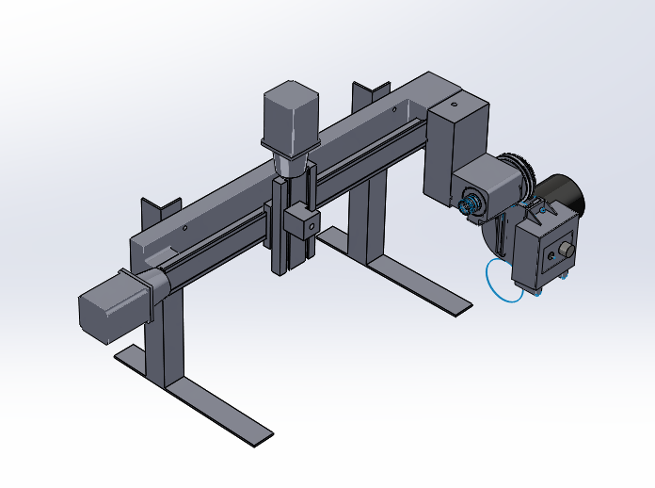

Extension

Tool Holder

**Figure 2.3:** Isometric view of the Electrochemical Lathe.

Schedule

**Table 3.1:**  Schedule including major task for completion of project in a hierarchy order



Table 3.1 shows the critical tasks for the project. The electrochemical lathe which was previously discussed will be completed by end of December. For this task, the motion control of the lathe was implemented by Simon Popecki while the machining of the extension in the spindle was elaborated by Carlos Graniello. The drawings displayed throughout this report have been created by a combined effort of both members of the team.

The most critical tasks of the project have been established to be the actual electrochemical lathe’s construction, since its design will determine the parameters of the entire system.

The working enclosure has been an ongoing process. It has been concluded that the material for this section would be mostly plastic, so the ECM process can be visible. The final design of this task can be appreciated on later stages of this report.

The machine support is vital as well. It is worth to remember that the transportation of the system is important. This means that the design of this support needs to be made such as to also account for any possible vibrations. As previously stated, this task has not been completely determined. The drawings in any figure in this report show a provisional support. However, this provisional support is being used as a base for the final design.

The pump system is also vital for the report. Its efficiency will play an important role on the speeds and feed rate applied to the machine. This task has been postponed until the support is completed, so the space available can be used wisely.

Finally, the power supply will be tested in combination to the rest of the project to determine the optimal voltage of operation (material dependent).

Analysis & Calculations

The results can be grouped primarily into three topics:

1. CNC Motion:

The motion of the axis was achieved by Simon Popecki who used the Bresenham’s Line Algorithm to calculate a line of motion.

This algorithm determinates the points of an n-dimensional plane to elaborate a best fitted line between two points. In practice, it is also known as an incremental error algorithm due the fact that the algorithm keeps an error bound at each point of the line as a function of the line’s slope.

To convert these Cartesian coordinates to digital motion, Simon wrote a G-code compiler. The compiler converted Cartesian coordinates and machine control operations in the standard G-code format to movement applicable to any CNC machine. Finally, stepper motors execute the movements of the compiled G-code commands.

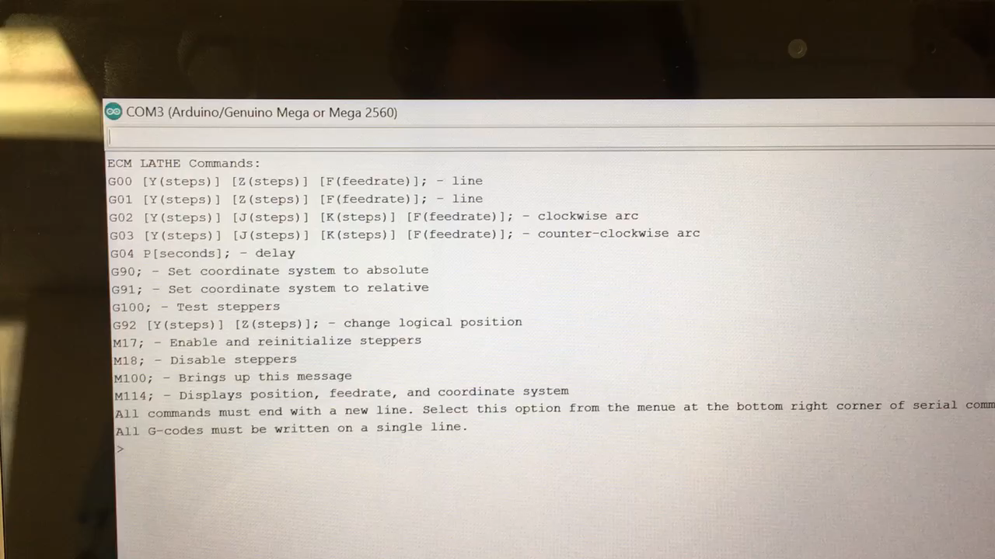

**Figure 4.1:** Example of the G-code responsible of movement

1. Spindle Extension:

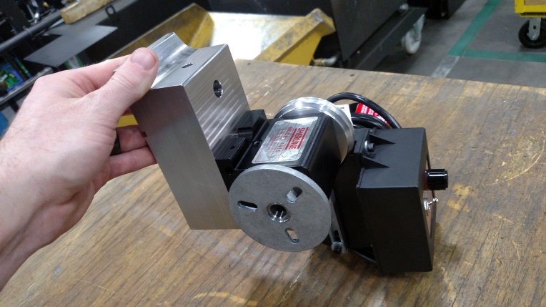

**Figure 4.2:**  Spindle extension for the ECM lathe

The extension was made from stainless steel 304 to prevent oxidation of the part. It was machined in a 3-axis mill by Carlos Graniello. Despite weight and manufacturability concerns, 304 was chosen due to the corrosive environment of ECM.

1. Machine Drawings:

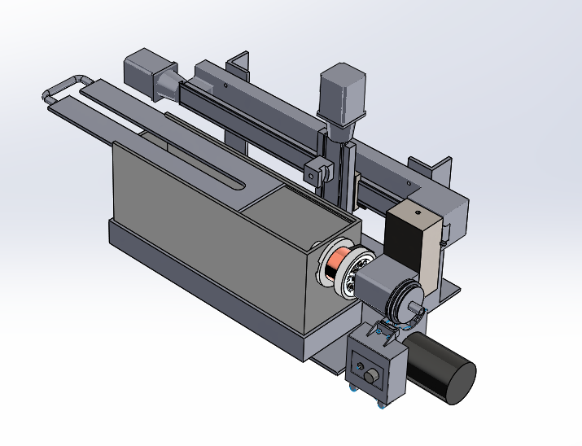

**Figure 4.3:** Detailed Electro Chemical Lathe Drawing

The conclusion of the drawings was a team effort from both students. These drawings were designed to constrain the design of the machine as a whole and to solve the challenges of design, for instance the transmission of electricity through the spindle, the work enclosure, and possible supports.

As mentioned before, the support of the machine is still in process. It is being considered to bolt the lathe into two separate legs made out of 304 stainless steel angle stock. A finite element analysis is being used to decide on the proper design.

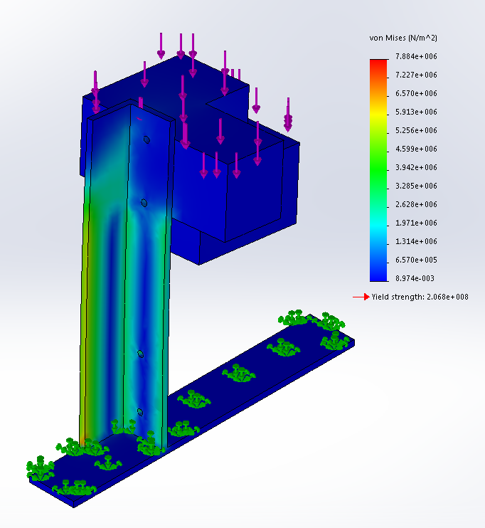

**Figure 4.4:** Stress analysis of a possible support design

The above figure shows a potential design that will support the lathe at 90 degrees. The block being held by the support is a representation of the weight of the extension with the addition of the spindle. A force of 10 pounds is applied to the upper block, representing the end of the lathe’s bed. The bottom block is being affected by a force of 20 pounds which is an over estimation of the weight generated by the spindle and the extension.

As it can be appreciated from figure (4.4) at an overestimation of the spindle’s weight, the material yield strength is of 206.8MPa and the maximum stress is witnessed to be 7.884 MPA. This means that using an angle stock to design the support of the system might be the right approach to take.

Summary

* Provide a summary of the project activities to date.
* Provide a description of the tasks left to be completed.
* Include a discussion of obstacles encountered and how they were resolved.
* Include a discussion of other potential obstacles.
* What will be the team’s first order of business at the start of the spring semester?

# Bibliography

CCCP (USSR). (1986). *ТЕХНОЛОГИЯ электрохимической обработки деталей В АВИА-ДВИГАТЕЛЕ-СТРОЕНИИ (Technology for Electrochemical Machining Aircraft Engine Components).* Москва (Moscow): "Машиностроение" ("Mechanical Engineering").

Leese, R. J. (2016). *ELECTROCHEMICAL MACHINING - NEW MACHINING TARGETS AND ADAPTATIONS with SUITABILITY FOR MICROMANUFACTURING.* London: Brunel University.

Li, H., Gao, C., Wang, G., Qu, N., & Zhu, D. (2016). *A Study of Electrochemical Machining of Ti-6Al-4V in NaNO3 solution.* Nanjing: Nanjing University of Aeronautics and Astronautics.

McGeough, J. A. (1974). *Principles of Electrochemical Machining.* New York: Springer US.

Wilson, J. F. (1971). *Practice and Theory of Electrochemical Machining.* New York: Wiley-Interscience.

Layout and Detailed Drawings

|  |  |
| --- | --- |
| **Figure 7.1:**  General Layout Drawing of the Electro Chemical Lathe | |
|  | 1. Frame for the working enclosure:   The frame is intended to hold the working enclosure in place at moments of operation. The material of the frame will be 304 stainless steel. |
|  | 1. Working enclosure with its lid:   The gap in the enclosure’s lid is intended to be for the cathode, since this will be operating from above.  The enclosure is designed in a box shape to contain the electrolyte around the part. |
|  | 1. Stepper Motor: NEMA   Two stepper motor will be use. One per each axis. |
|  | 1. Lathe’s bed:   The dimensions of the part were taken from the lathe’s bed that was purchased. |
|  | 1. Base:   Made out of aluminum, the base that will be used for this project is the base that was purchased with the lathe. |
|  | 1. Leg supporter:   There will be two 304 SS leg supporters holding the lathe. The frame of the working enclosure will be resting on these supporters. |
|  | 1. G18 Crosslide supporter:   Made of aluminum. It came with the lathe. |
|  | 1. Crosslide:   Made of aluminum. It came with the lathe. |
|  | 1. Tool post:   It came with the lathe. It is made of aluminum. |
|  | 1. 304 SS Extension. |
|  | 1. Head:   The head consist of the following parts: headstock, faceplate, headstock spindle, DC motor, drive pulley, belt, and speed control assembly, among others. |
| 1. The transmission will isolate/hold the part from the system and it will be located in the hole of the enclosure (2) | |
|  | * 1. Spindle disk (SS) |
|  | * 1. Primary insulator (PEI) |
|  | * 1. Rotor (Copper) |
|  | * 1. Secondary insulator (PEI) |
|  | * 1. Bearings (ceramic) |
|  | * 1. 100 Amp Brush (Graphite) |